Image Messaging and Story Posting Social Media Platform

|  |  |  |  |
| --- | --- | --- | --- |
| **Aaska Shah** [shaha8@mcmaster.ca](mailto:shaha8@mcmaster.ca) 001422791 | **Kerala Brendon** [brendokh@mcmaster.ca](mailto:brendokh@mcmaster.ca) 001424625 | **Nolan Slade**  [sladenj@mcmaster.ca](mailto:sladenj@mcmaster.ca) 001401079 | **Vyome Kishore** [kishov@mcmaster.ca](mailto:kishov@mcmaster.ca) 001406201 |

# ABSTRACT

DESIGN, GROUP 4 - The usability critiques of four image messaging social media platforms and a proposal for an improved application are presented. The four platforms to be critiqued using Norman’s 7 Principles of Design [1] are Snapchat, Facebook Messenger, Instagram, and WhatsApp. The proposed new application will focus on the ability to send image messages to other users and to post images and video stories. This proposal also discusses a description of the final product and the development work breakdown.

# INTRODUCTION

With 88% of 18 to 24-year-olds using social media [2], these platforms have become an important aspect of an individual’s social life. The ability to send image and video messages to friends is considered a necessary functionality for social media users. Many users also wish to share their images and videos to a wider audience temporarily by uploading a story.

We propose an application for image messaging and story posting with an intuitive interface designed through careful analysis of issues plaguing today’s most prominent multimedia messaging platforms.

# Software Class Analysis

Within the class of multimedia messaging platforms, these four products are the most popular. Over time, these applications have evolved from originally simplistic functionality to complex applications with problem-laced interfaces to match. Affordances provided by many of these applications that we believe can be improved are the ability to send image messages and post story statuses.

Stories typically last 24 hours and social media users often use them to publicly share their current activity or feelings. Being able to easily and quickly post a story is important to maintaining a social media presence.

Sending an image or video privately to another user or group of users is another important aspect of maintaining virtual relationships. Sending an image allows users to better express their message and emotions.

# Final Product Description

The final multimedia messaging platform will focus on creating an improved image messaging and story posting application. The improvements will be based on our survey of Instagram, Facebook Messenger, Snapchat and WhatsApp.

The user tasks that will be targeted for improvement include messaging and story posting. As well, we aim to implement appropriate signifiers such that these affordances provided to the user are easily discoverable. Finally, the user’s conceptual model of the search functionality will be well delivered.

As the goal of this project is to offer improved navigation and usability over existing products, development efforts will be focused on producing a functional, intuitive interface rather than a full-fledged messaging application. Subsequently, the aim of the group is to statically define messages and other content to be displayed during a demonstration of the final revision of the product. Navigation and other interface capabilities will be functional.

# Survey of Social Media Platforms

## Snapchat Critique

This multimedia-messaging platform has quickly become ubiquitous in most parts of the world. The application is used to distribute images and videos (‘snaps’) to an individual or publicly. The catch of this application is that a recipient can only view the snaps for a limited amount of time before it disappears. This makes it perfect for quickly capturing and sharing interesting things or just chatting using pictures.

The first critical flaw with Snapchat pertains to its text messaging functionality. Upon opening the app the user is presented with the camera open (Figure 1). If the user wishes to send a text message, instead of an image message they must press the chat box button in the bottom left corner. The user must then either select a recent contact or search for the contact they wish to message before they are brought to the text messaging screen. Because it takes two to three clicks to arrive at the text messaging screen, and the opening screen does not afford the ability to send a text message, it does not allow for good discoverability for sending a message.

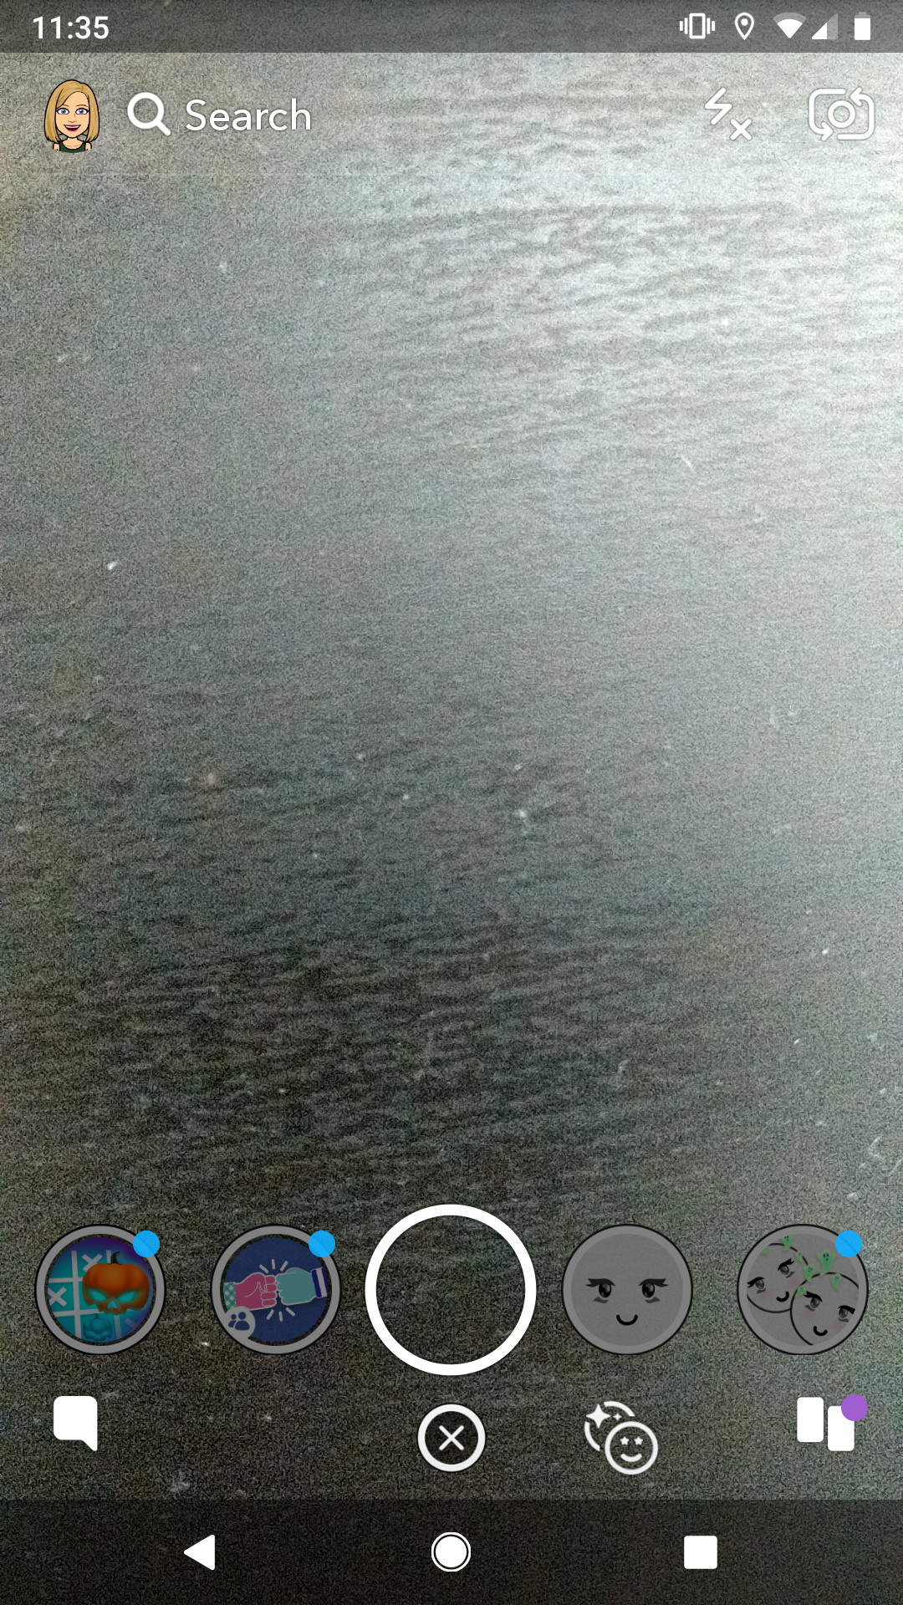

**Figure 1. Screenshot of Snapchat to show the view upon opening.**

Another flaw with Snapchat is within the text messaging feature. A new message will disappear once the user has read the chat and exited that screen. However, by tapping on a message, the user is able to save it (Figure 2). The ability to save a message is not obvious – no clear signifier is provided to the user.



**Figure 2. Screenshot of Snapchat’s messaging screen showing one saved (greyed) and one unsaved message.**

## Facebook Messenger Critique

Facebook Messenger, also known simply as ‘Messenger’, is a mobile communication application that allows Facebook members to exchange multimedia messages. Messages sent through this application can be received on Facebook’s desktop site, Facebook’s Messenger web application, as well as native applications on most popular mobile devices, including smartphones. Messages can contain a combination of text, images, videos, and stickers. Messenger also allows users to post image or video stories.

A first usability issue would be the generally poor layout of some interface components used to send a message. This poor layout may result in the user taking actions inadvertently. For example, the ‘thumbs up’ icon on the right side of the text input space (Figure 3) is located directly where a right-handed user would naturally place their thumb to scroll through previous chats. As such, many users accidentally send these icons; furthermore, there is no possible way to cancel the icon from being sent or otherwise delete it once this inadvertent action has taken place. This issue is also observable in the ‘Active’ window, where users can unintentionally ‘wave’ to other users since the wave button lies where the user would naturally place their thumb to swipe through screens.

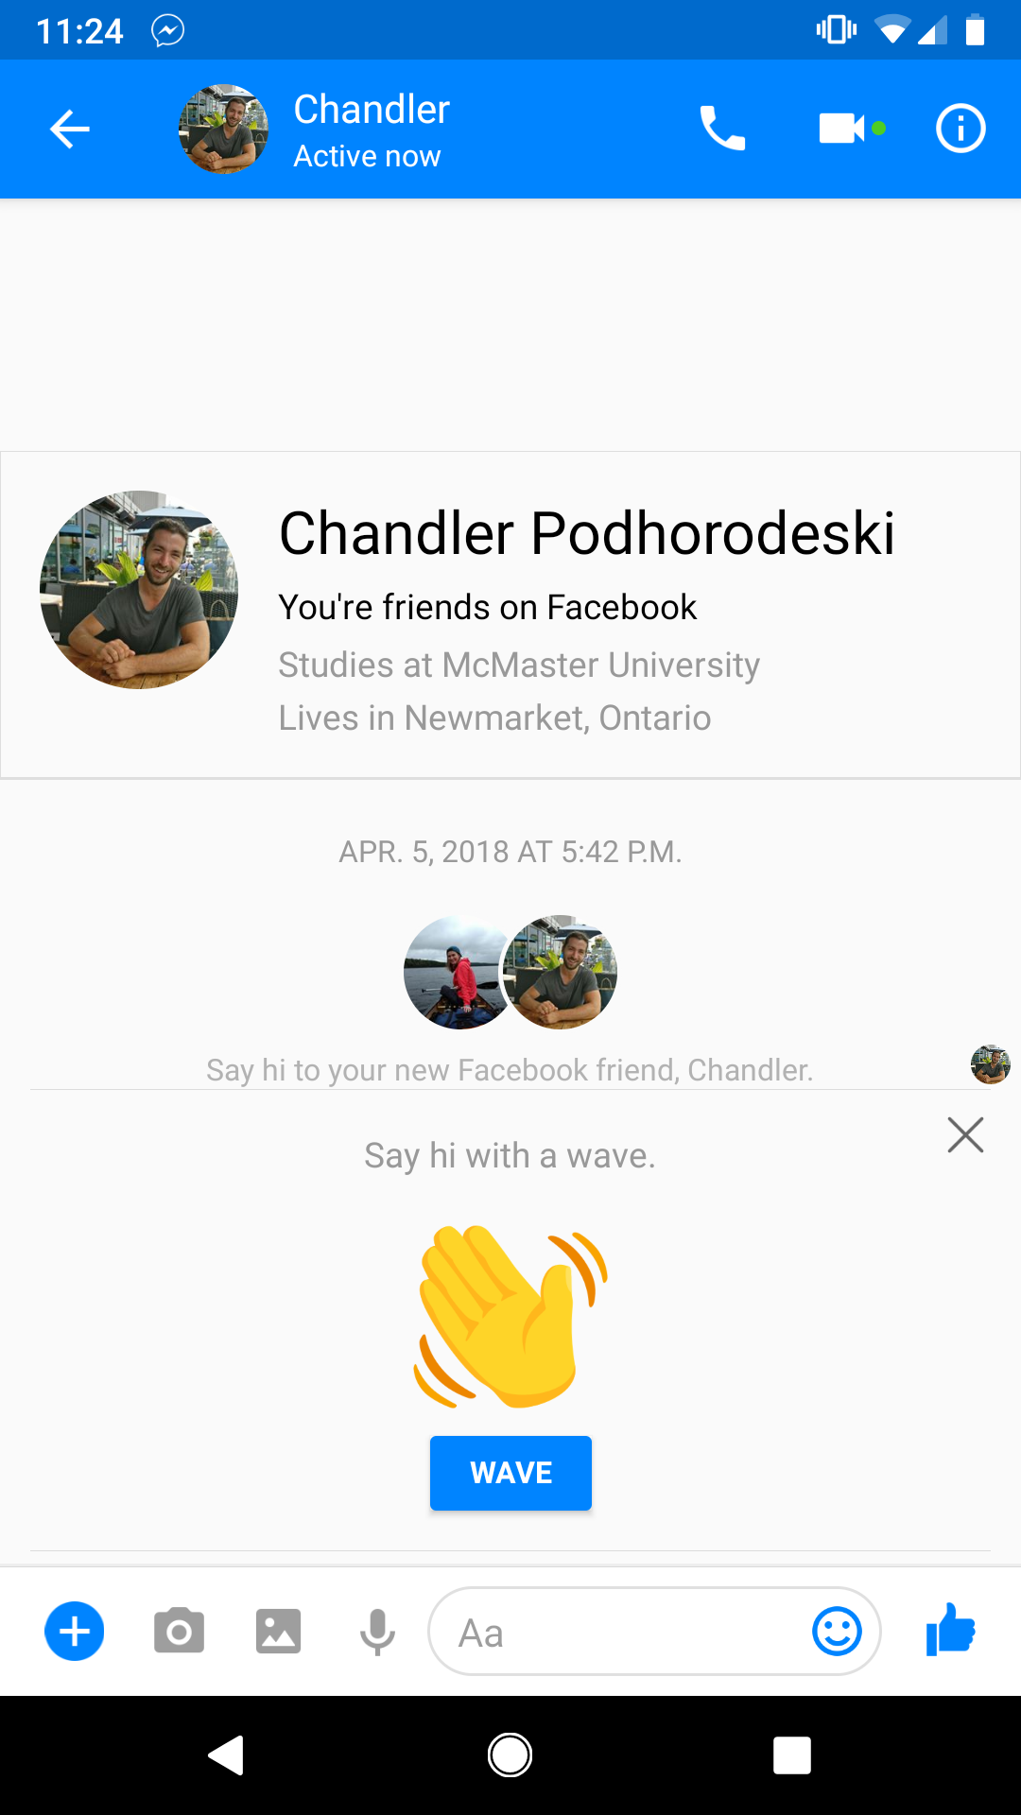

**Figure 3. Screenshot of Messenger to show the thumbs up button in the bottom right corner.**

A second usability issue pertains to poor discoverability throughout the interface. For example, there is no indication to the user that tapping the small circle containing their photo in the top-right corner (Figure 4) will bring them to their profile summary and settings. This is a byproduct of poor signifiers and mappings - something that could be amended with appropriate text headings and well-mapped icons.

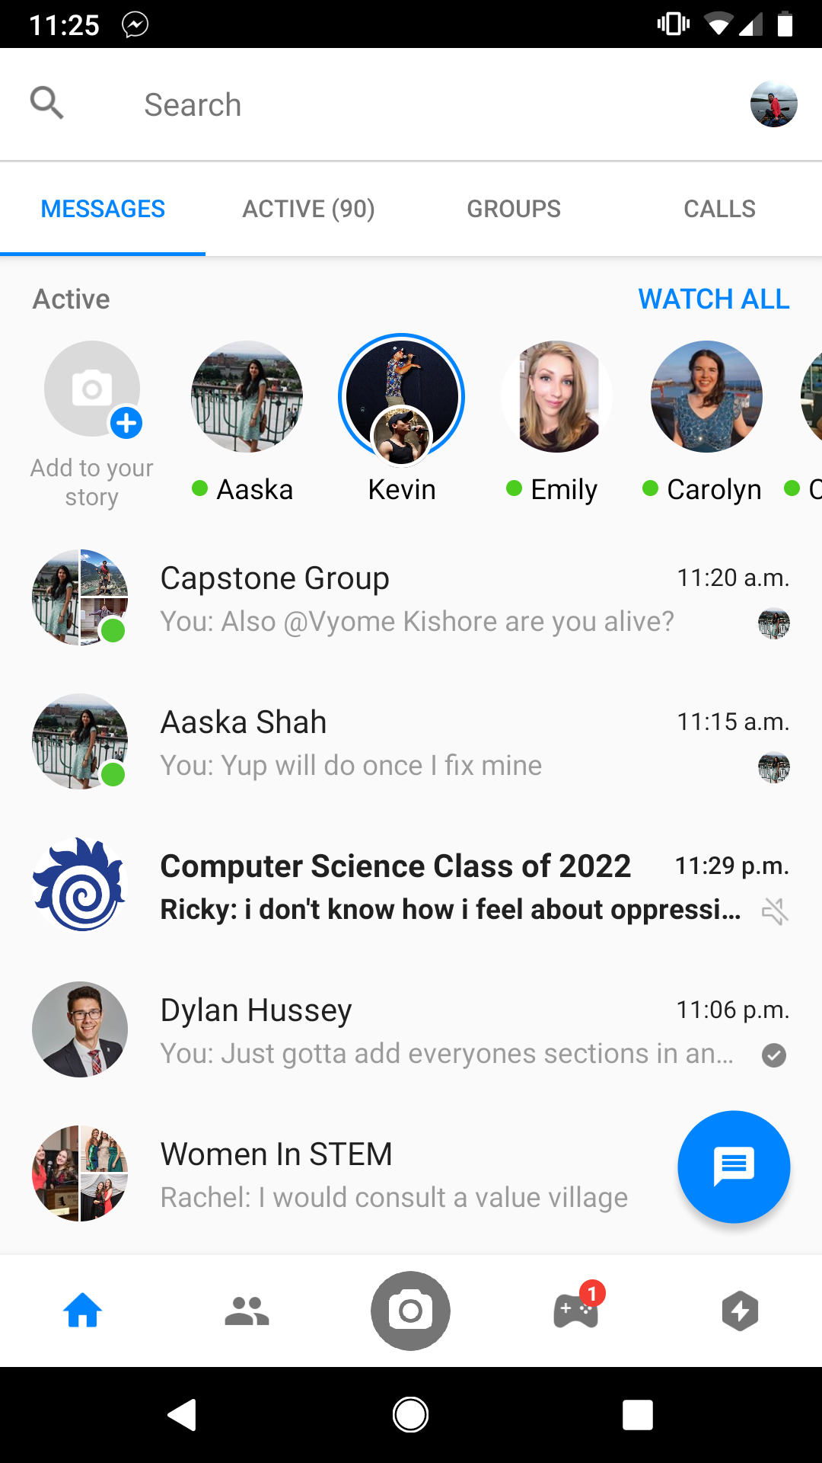

**Figure 4. Screenshot of Messenger to show the profile access in the top right corner.**

These usability flaws could result in users becoming frustrated. Inadvertent actions can lead to embarrassment and annoyance, while poor discoverability throughout the interface fosters confusion and prevents users from naturally forming a strong conceptual model of the application.

## Instagram Critique

Instagram is a popular social media platform focused on allowing users to post photos that can be viewed by their followers. The main affordances provided to the user by the application are to scroll through content posted by other users, and to allow their followers to like and comment on posts. Instagram also supports posting stories that last 24 hours; plus, users can partake in instant messaging with text, images, and videos.

Instagram overall has an effective messaging and story interface. The central usability flaw is the lack of affordance and discoverability of the messaging portion of the application. Upon opening the application, the user sees a series of image posts by users they follow (Figure 5). To send someone a photo message, the user must either enter the creating story screen or the messaging section. To enter the create story screen, the user can either swipe the screen to the right or press the ‘Your Story’ bubble in the top left of the screen (Figure 5). There is no signifier for swiping to the right and the bubble is signified solely with a plus sign. To enter the messaging screen, the user must press the arrow button in the top right corner of the screen (Figure 5). Both options add an extra step for the user, which is not ideal if they wish to send or read a message quickly.

To post a story, the user can use either of the options above: either swipe to the right or press the ‘Your Story’ bubble in the top left. Both require an extra step upon entering the application. Similarly to above, this is a problem if the user is attempting to capture an event quickly.

Overall the actual messaging and story creation portion of the application is done well but getting to these screens is tedious.

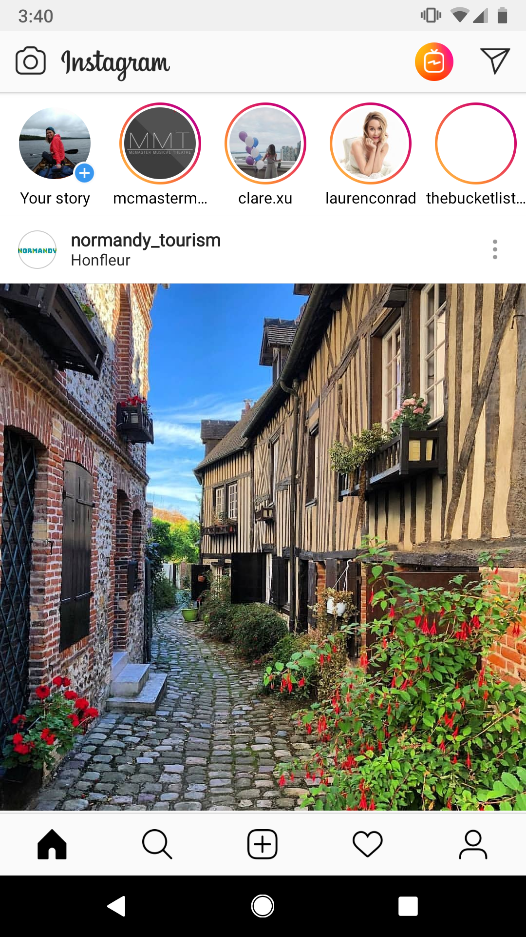

**Figure 5. Screenshot of Instagram upon opening.**

## WhatsApp Critique

WhatsApp is a cross-platform multimedia messaging application that allows users to send text, videos, images, and documents to their phone’s contacts. WhatsApp’s design is relatively generalized to account for all types of users.

Posting a story on WhatsApp does not follow the conceptual model already established by other messaging and story posting applications. Instead of using the term “story” it uses “status”, which is unlike Instagram, Facebook Messenger and Snapchat. There is even further confusion after selecting or taking an image to add as the user’s status. On the “Select Contacts” page there is a “My Story” option with the sub-title “Send to my contacts” (Figure 6). This is a poor signifier as the user is unsure if it will send a notification to all their contacts about this status, or if it will just exist as their status on their profile.

The process of selecting a message recipient can be difficult. If the user clicks the profile image of the user, instead of their name it triggers a pop-up (Figure 7). The pop-up gives the user an option to send that user a message, call them, video call them or see contact info. This is confusing as the user explicitly decided to send a message, so they wouldn’t expect to need to make that decision again.

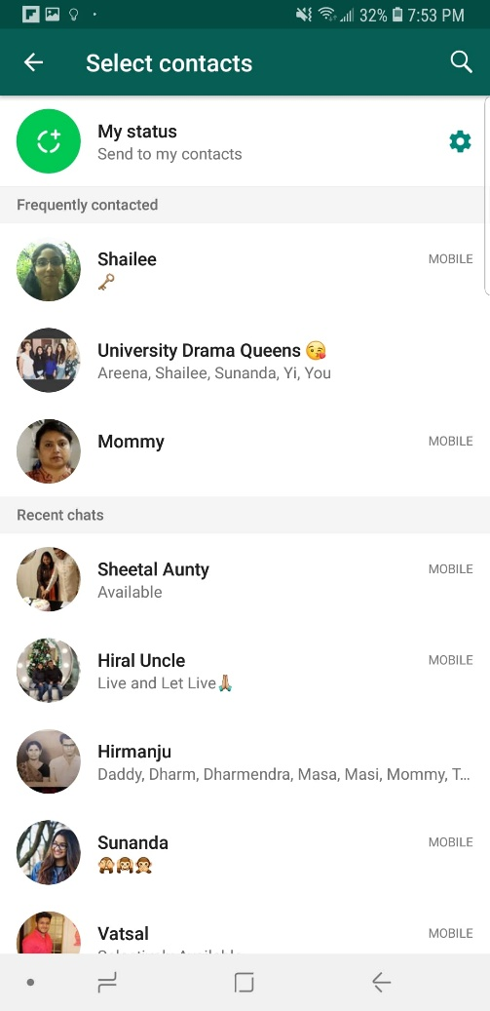

**Figure 6. Screenshot of WhatsApp screen with adding image to status.**

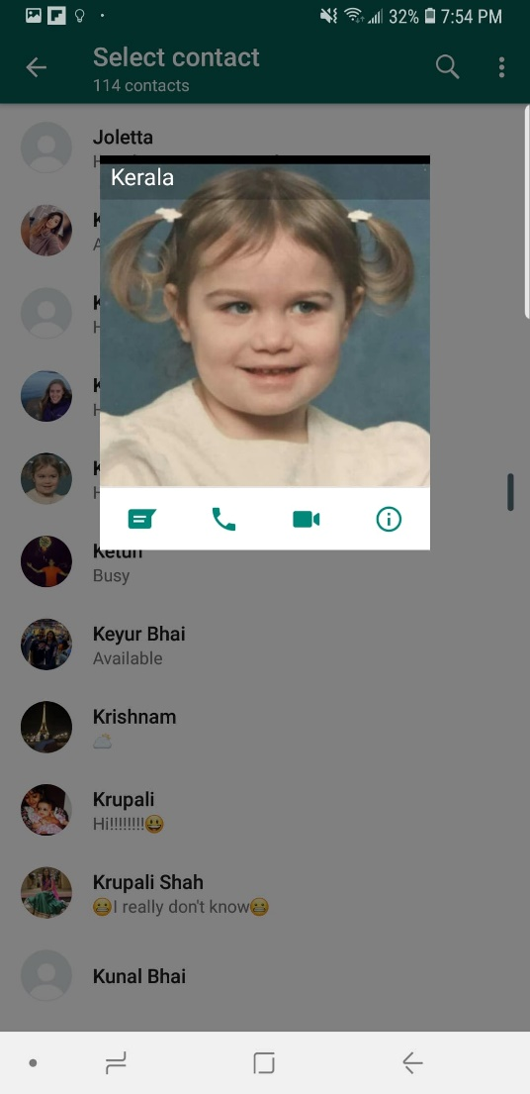

**Figure 7. Screenshot of WhatsApp screen with selecting contact to send a message to.**

# Development Work Breakdown

Before work on the development side can begin, application functionality must be finalized and research into appropriate technologies must be completed by all members of the team. During the first stage of development, a rudimentary design will be produced. This design will consist of non-technical components including a storyboard style description of application views and their corresponding interfaces.

Once these components are finalized, all team members will be responsible for portions of the interface development. Tasks will be focused around visual and functional components, with members assigned to completing implementation of a specific functionality within the interface.

A formal breakdown is as follows,

Messaging: Kerala Brendon

Search: Aaska Shah

Story Posting and Viewing: Vyome Kishore

Project Lead, Core Design: Nolan Slade

In the above breakdown, the project lead will be mainly responsible for ensuring consistency and completion across all functionalities within the interface.

# REFERENCES

1. Norman, D., 2013*. The Design of Everyday Things: Revised and Expanded Edition*, New York: Basic Books.
2. Smith, A. and Anderson, M., 2018. Social Media Use 2018: Demographics and Statistics. *Pew Research Center: Internet, Science & Tech*. http://www.pewinternet.org/2018/03/01/social-media-use-in-2018/.

**Facebook Messenger HTAs**

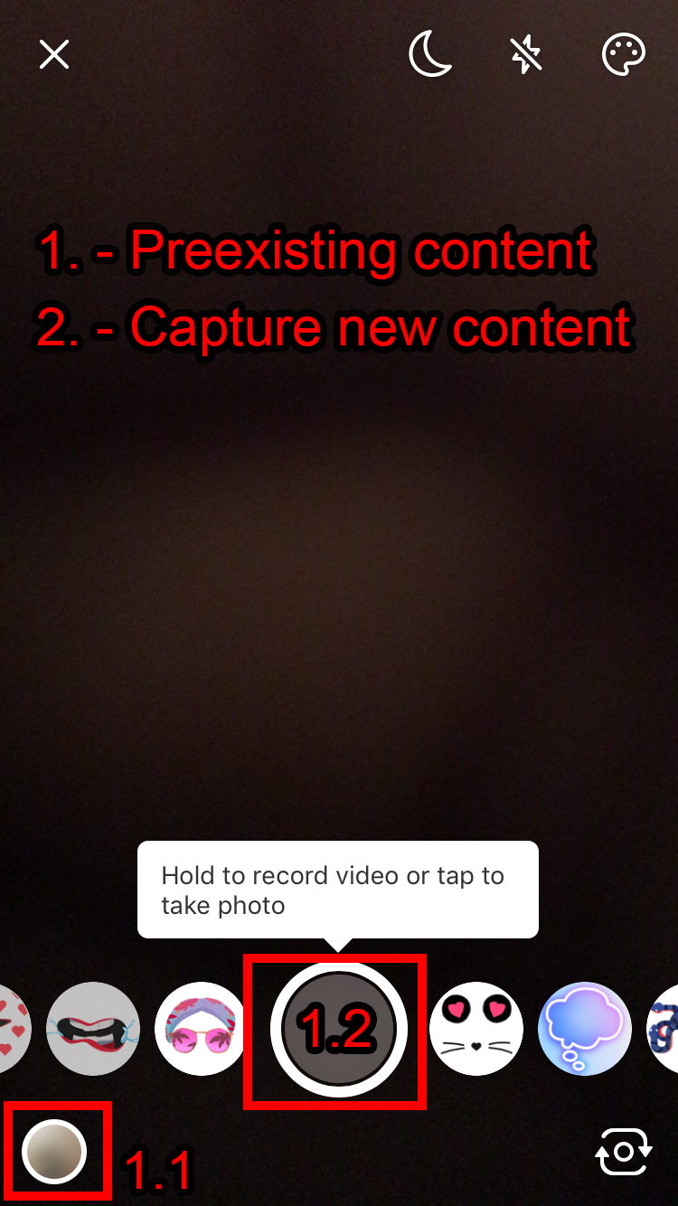 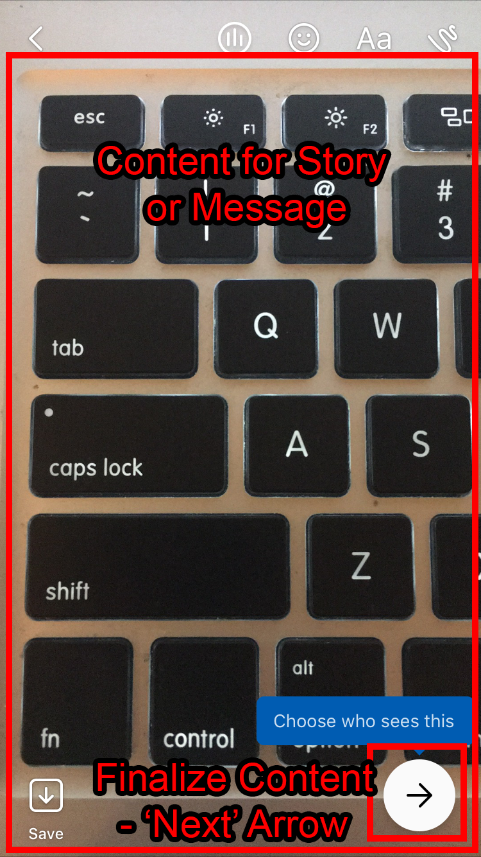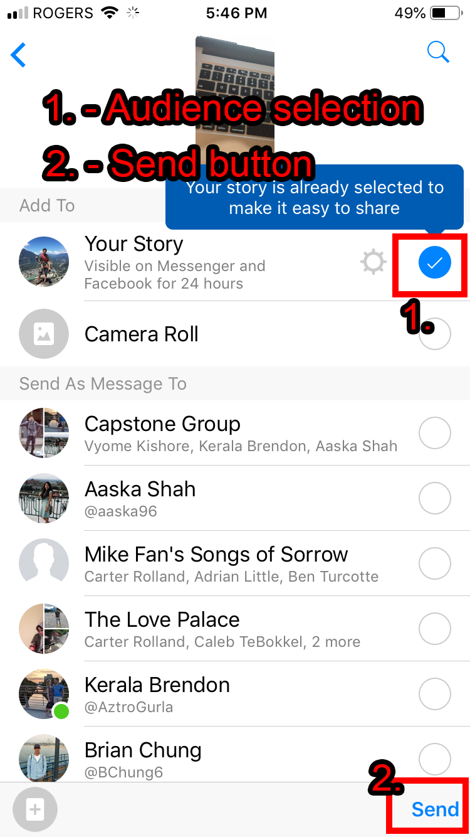

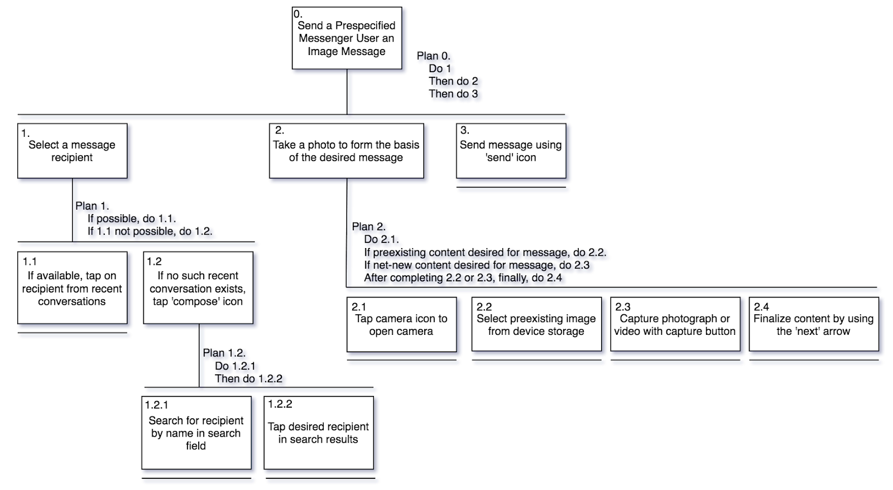

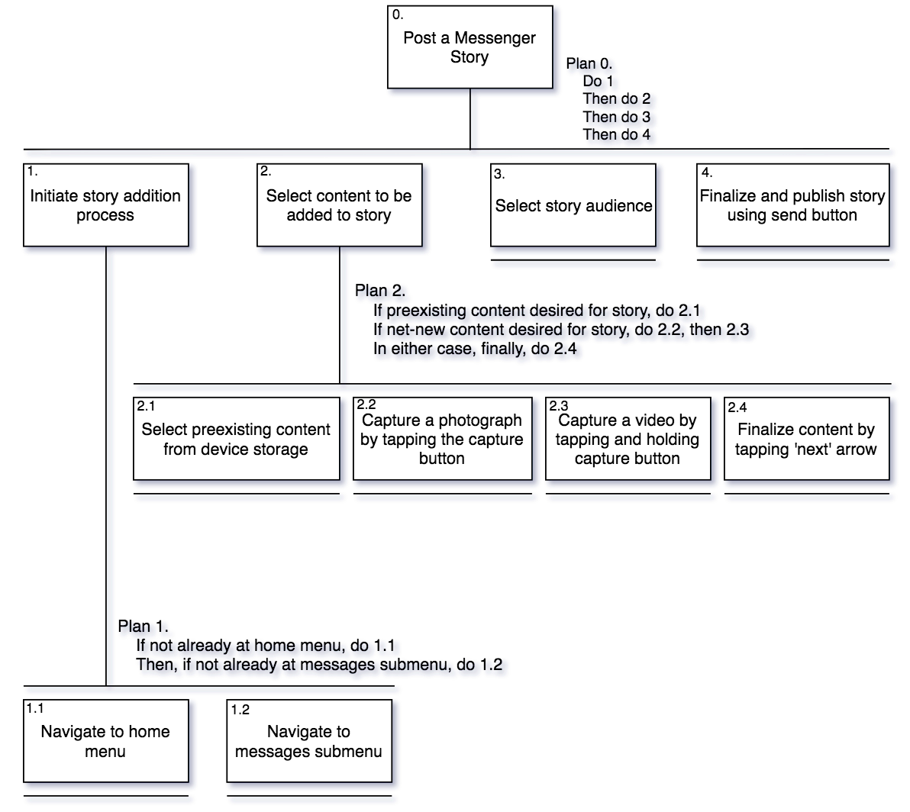

**WhatsApp HTAs**

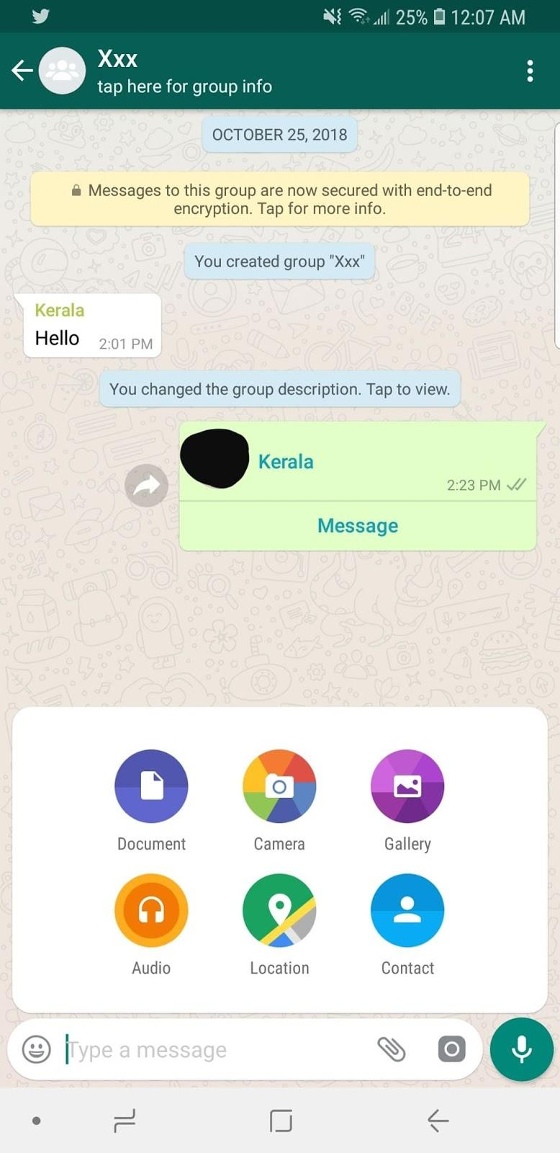 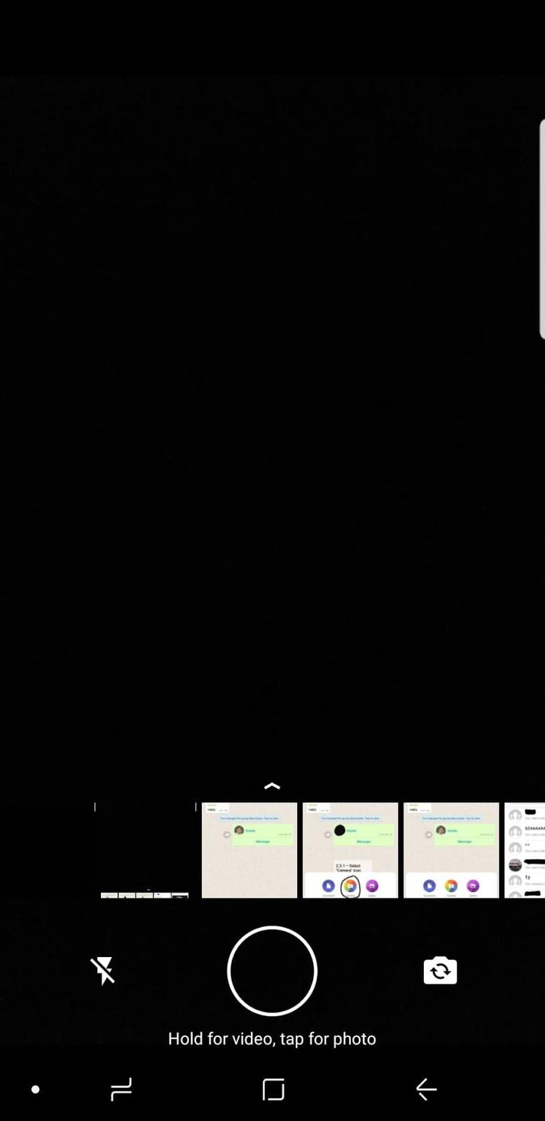 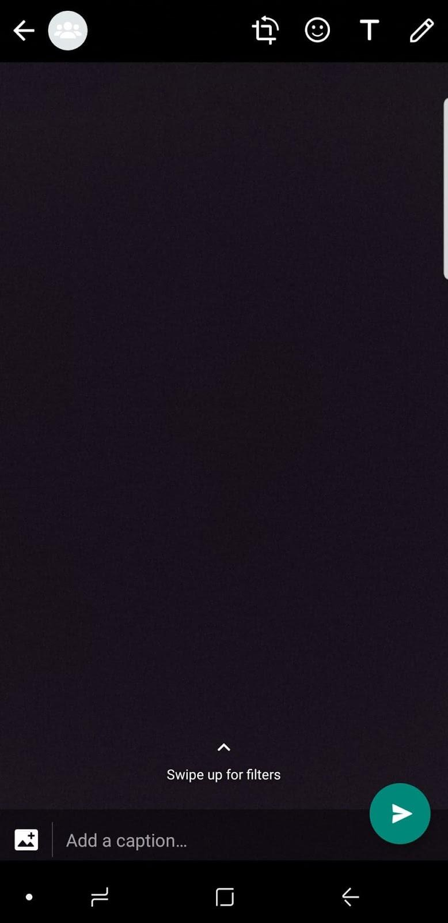

**(i)                      (ii) (iii)**

**Figure: (i) Clicking on paperclip icon shows options to attach different types of media. (ii) When clicked on the camera, you can tap the circle to take a picture. (iii) By clicking the arrow, it will send to the Xxx.**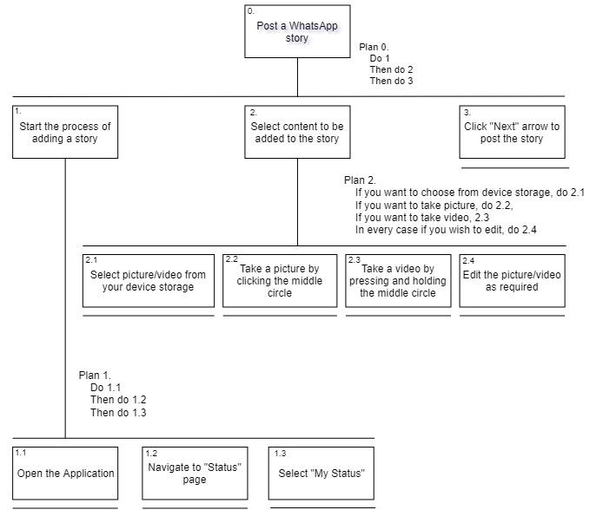

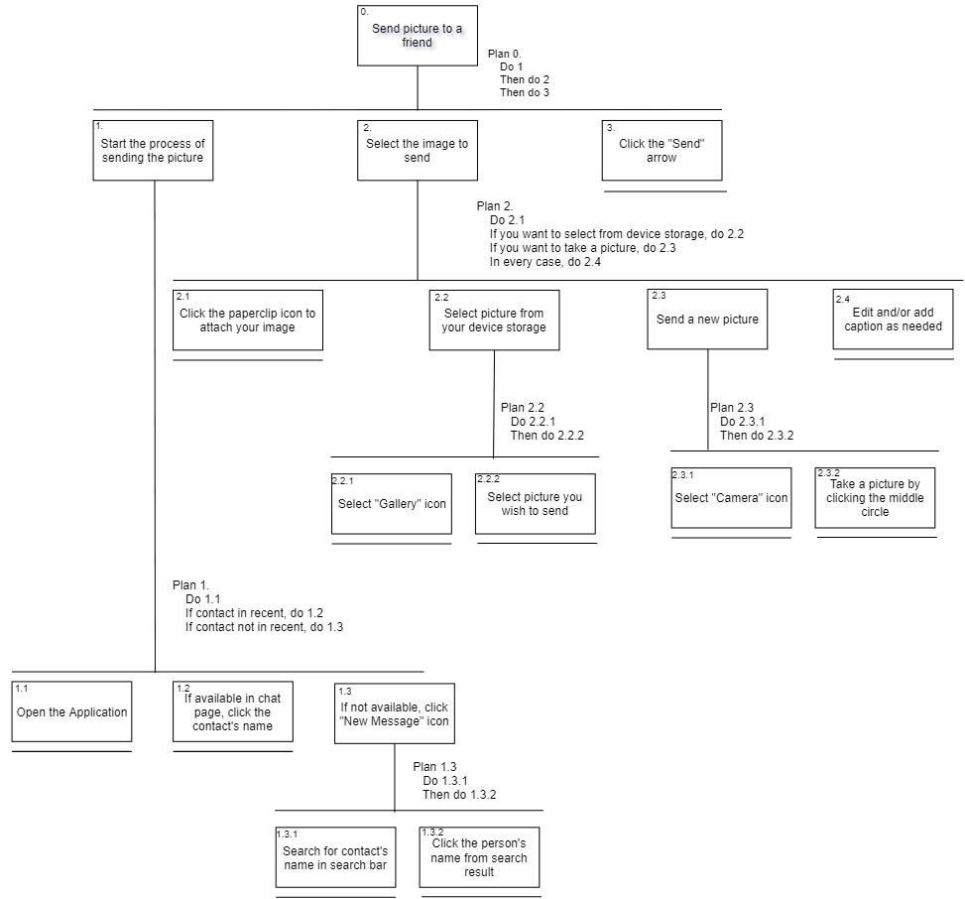

**Instagram HTAs**

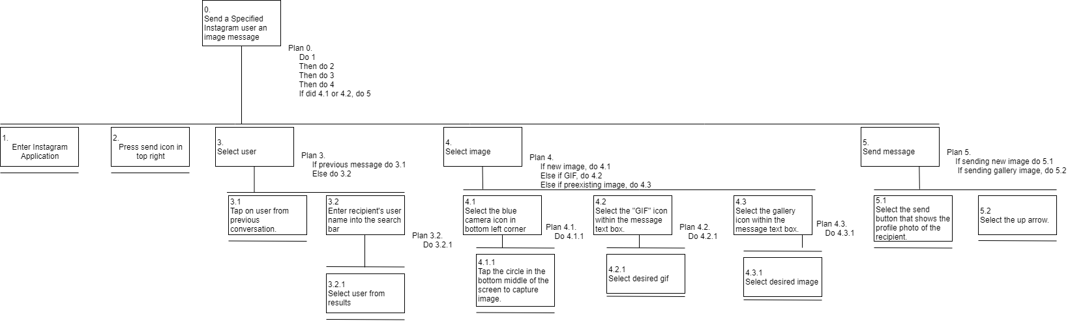

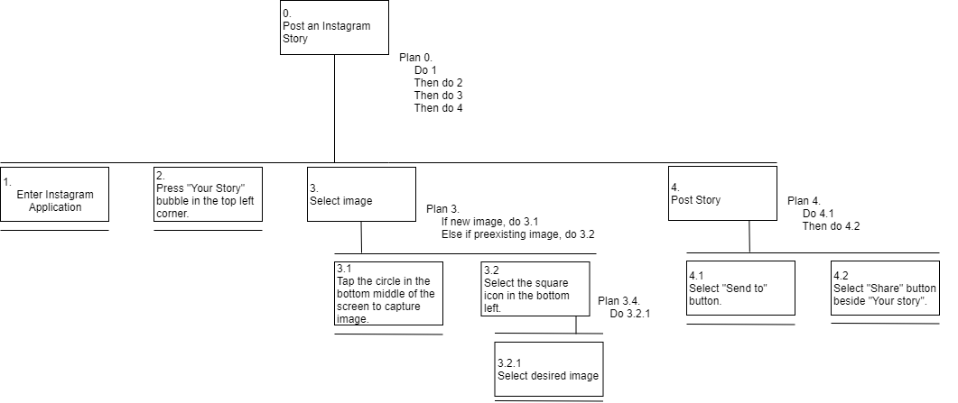

**Snapchat HTAs**

